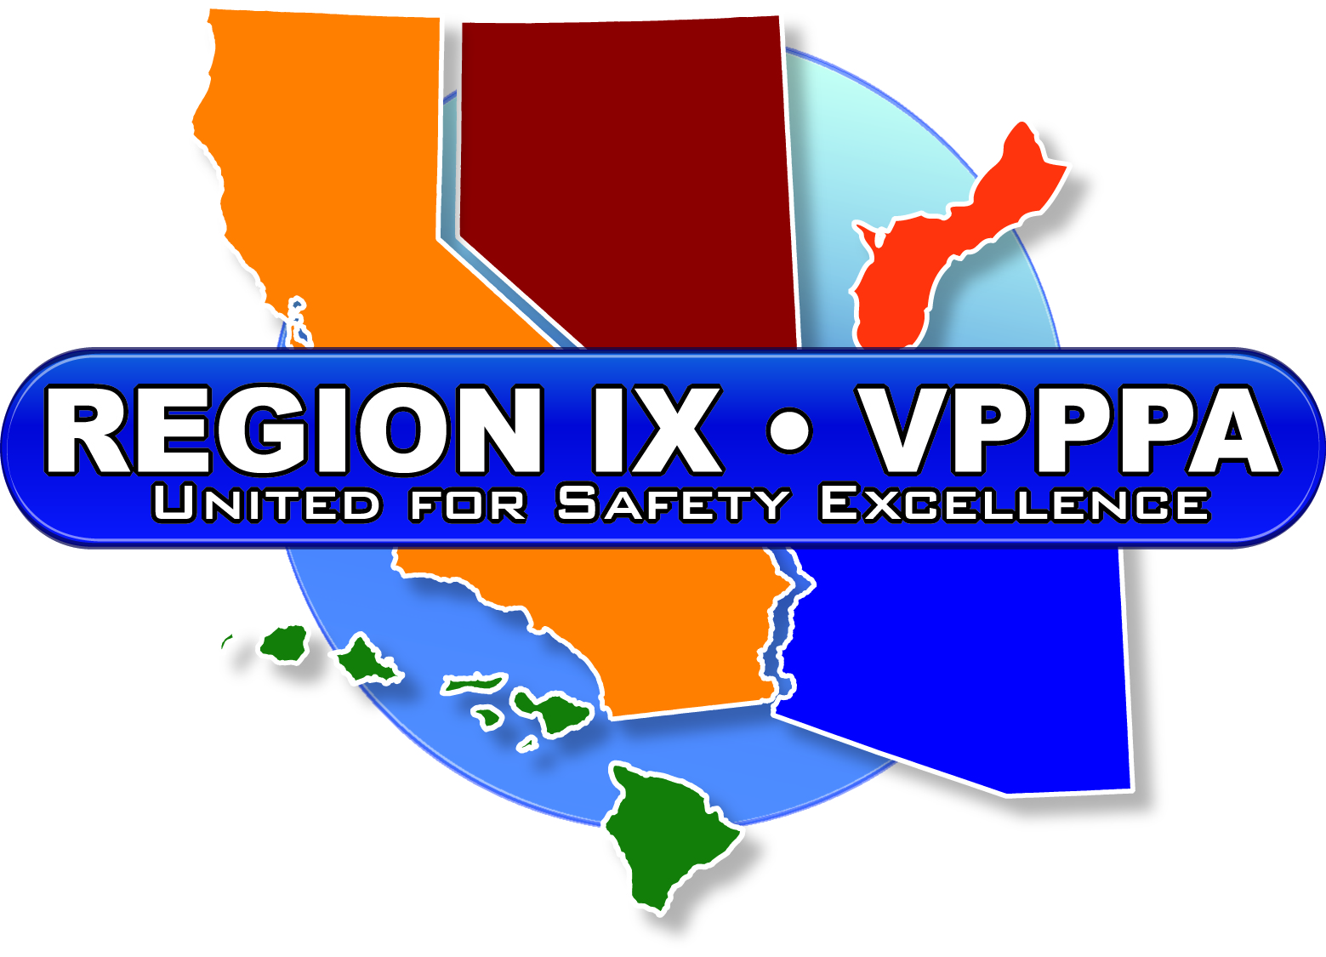

April 12, 2021
Dear VPPPA Member;

In accordance with our Chapter By-Laws, we will be having open elections for the Region IX Board of Directors in 2022. These elections will take place in conjunction with our Regional Summit in Las Vegs, Nevada on April 26 - April 28, 2022. Meeting details will be sent out through Constant Contact Prior to the meeting. The following positions will be up for re-election:

- Vice Chairperson
- Treasurer
- Representative from a Site with a Collective Bargaining Agreement
- Director-At-Large (3 positions)

If you are interested in nominating someone, or yourself, for any of the above Board of Director positions, please fill out the attached Nomination form and return it to Don Bracken – Secretary - VPPPA Region IX Board of Directors at the address indicated on the form. Completed forms must be received no later than March 26, 2022.

Please direct any questions regarding the nomination or election process to Paul Modjesky - Chairman, VPPPA Region IX Board of Directors at (707) 731-3318, or by email at Paul.Modjesky@valero.com.

On behalf of the Board, I thank you for your support of the VPPPA, and I look forward to seeing you at our 2022 Regional Summit in Las Vegas, Nevada.

Sincerely,
Paul Modjesky,
Chairman-VPPPA Region IX Board of Directors

2022 NOMINATION FORM FOR VPPPA REGION IX BOARD OF DIRECTORS

☐ Check here if self-nomination

Seeking the Position of:
☐ Vice Chairperson ☐ Treasurer
☐ Rep. from a site with CBA ☐ Director at Large

Name: Click here to enter text.
Company Name: Click here to enter text.
Mailing Address: Click here to enter text.
City, State, Zip: Click here to enter text.
Phone: Click here to enter text. Email: Click here to enter text.

PLEASE DESCRIBE YOUR QUALIFICATIONS AND WHY YOU ARE SEEKING THIS POSITION ON THE REGION IX BOARD. NOTE: 300-WORDS MAXIMUM

Click here to enter text.

I HAVE READ AND REVIEWED THE ATTACHED “ELIGIBLITY REQUIREMENTS” AND THE “RESPONSIBILITIES OF OFFICERS” WITH MY MANAGEMENT AND HAVE OBTAINED THEIR SUPPORT, ESPECIALLY AS IT RELATES TO TRAVEL COSTS, TIME AND TIME AWAY FROM WORK.

SIGNED:

DATE:

If you wish to nominate yourself or someone else for a Board position, please complete this form and return to the address below by March 26, 2022.

Don Bracken
Raytheon
1151 E. Herman’s Rd
Building 826
Tucson, Arizona 85756
(520) 794-0745
William.D.Bracken@rtx.com
Eligibility Requirements:

Your site must be a member in good standing (Full, Corporate, or Agency) with the National and Region IX Chapters of the VPPPA.

Your site must be a VPP STAR site in California, Arizona, Nevada, Hawaii or Guam.

You may not have more than one (1) additional member of your organization participating on the board at the time of the election.

You must be willing to actively participate in the Board’s activities and provide, to the Board’s Secretary, and provide a letter of support for time/travel/expenses from your organization’s management.

Region IX VPPPA Chapter By-Laws

Article IV

Responsibilities of Officers

Chairperson (1)
Responsibilities include:
- Initiate and conduct planning sessions for annual regional meetings and representation at national meetings
- Coordinate planning sessions for future meetings
- Maintain general control of meetings
- Be the contact with the National VPPPA and OSHA on all matters relative to the VPPPA
- Attend National VPPPA Board meetings as a non-voting representative of the Region and participate in Chapter Chair meetings or conference calls

Vice-Chairperson (1)
Responsibilities include:
- Act in behalf of the Chairperson in his or her absence
- Assist the Chairperson in the coordination and conducting of all meetings
- Keep the Chairperson abreast of changes or happenings within the VPPPA
- Work with hosting Officers for any special arrangements to ensure meetings are productive and profitable
- Coordinate the activities of the sub-committees and assist the sub-committee Chairpersons as necessary to conduct sub-committee business

Director At Large (4)
Responsibilities include:
- Assist the Chairperson in the coordination and conduct of all meetings
- Keep the Chairperson abreast of changes or happenings within the VPPPA
- Work with hosting Officers for any special arrangements to ensure meetings are productive and profitable
- Coordinate the activities of the sub-committees and assist the sub-committee Chairpersons as necessary to conduct subcommittee business

Secretary (1)

Responsibilities include:
- Maintain a current member site contact list
- Prepare and ensure that minutes of all meetings are prepared and distributed in a timely manner
- Prepare and ensure distribution of all minutes to member site contacts within thirty days (30) of any meeting or teleconference call

Treasurer (1)
Responsibilities include:
- Ensure the collection of all registration fees and that custodial care of VPPPA funds are handled in the proper manner
- Make all payments for expenses incurred by the VPPPA in conduct of its annual meeting, or any other expenses approved by the Officers of the VPPPA
- Establish and maintain a VPPPA interest-bearing checking and/or savings account
- Report to Officers and the National VPPPA on the financial status of the Region IX VPPPA Chapter

Representative from a Site with a Collective Bargaining Agreement (1)
Responsibilities include:
- Assist the Chairperson in the coordination and conduct of all meetings
- Keep the Chairperson abreast of changes or happenings within the VPPPA
- Work with hosting Officers for any special arrangements to ensure meetings are productive and profitable
- Coordinate the activities of the sub-committees and assist the sub-committee Chairpersons as necessary to conduct subcommittee business

Representative from a Site without a Collective Bargaining Agreement (1)
- Responsibilities include:
- Assist the Chairperson in the coordination and conduct of all meetings
- Keep the Chairperson abreast of changes or happenings within the VPPPA
- Work with hosting Officers for any special arrangements to ensure meetings are productive and profitable
- Coordinate the activities of the sub-committees and assist the sub-committee Chairpersons as necessary to conduct subcommittee business

Board Members-All
- Attendance in monthly conference call for region (1 hour)
- Preparation for Regional VPPPA Summit (Annual time commitment 16-32 total hours)
- Attendance at Regional Summit - required
- Attendance at National VPPPA Symposium-desired

