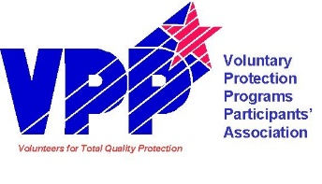
2024 REGION IX VPPPA SAFETY SUMMIT SPONSORSHIP
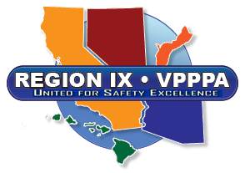
The Region IX VPPPA Board of Directors is excited about your 2024 Annual Region IX VPPPA Safety Summit to be held April 16th-18th, 2024 at the Grand Sierra Resort and Casino in Reno, Nevada! This summit is expected to host over 200 attendees from the Region IX area.
Based on the 2022 Region IX VPPPA conference evaluations, participants were delighted with the exceptional networking and educational opportunities offered and are greatly anticipating the summit in 2024. The Region IX VPPPA Board of Directors is aggressively securing exhibitors and speakers for the conference and is encouraged by the numerous participants that have already expressed interest in our 2024 conference.
To demonstrate your commitment to safety and health excellence, to VPP and to your Region IX VPPPA, please reserve your sponsorship today. Reserving your sponsorship early will ensure your company recognition at the 2024 Region IX VPPPA Safety Summit and provide exposure as an advocate for safety and health excellence through visibility and announcements. Sponsorships are essential for the success of the regional summit.
Region IX VPPPA sponsorship opportunities have been tailored to fit any budget. Interested companies can select from a comprehensive range of sponsorship options and levels. In conjunction with our Safety Summit, all sponsors are recognized as part of the Region IX Team!
Sponsorship levels are as follows:
Diamond: $10,000 and above Silver: $2,500 to $4,999
Platinum: $7,500 to $9,999 Bronze: $1,000 to $2,499
Gold: $5,000 to $7,499 Contributor: $750

In addition to selected sponsorship options and/or events, your company name, logo, and the level of sponsorship will be provided to all attendees and will be prominently displayed:
• Official Summit Program
• Opening and all General Session Events
• Exhibit Hall Entrance
• Region IX VPPPA website

Back again for 2024! We have added a selection of sponsorship options that will provide your company even greater recognition and visibility as well as the ability to direct your sponsorship funds! These are filled on a first come, first served basis so don’t delay.
Thank you for your support and participation at your 2024 Region IX VPPPA “Revival in Reno” Summit. The Board is looking forward to your attendance in Las Vegas!
Respectfully,
Don Bracken
Region IX VPPPA Chairperson
William.D.Bracken@rtx.com
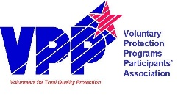
SPONSORSHIP LETTER OF COMMITMENT
INSTRUCTIONS: Legibly complete this Sponsorship Letter of Commitment and submit it to the Region IX VPPPA at the address and email below to confirm your sponsorship. VPPPA is a 501(c)(3) charitable organization. Contributions are 100% tax deductible. Region IX VPPPA’s Federal Tax ID# is 91-2130596.

PLEASE PRINT OR TYPE
Contact Name Title
Address
City State Zip
Phone Fax Email
Company Name (As it should appear)
Please Select Sponsorship: |  |  | Payment Methods
Diamond  $10,000 | * Primary Summit Sponsorship (Recognition / Company logo as main summit sponsor) |  | Total Payment $  * Check delivery by 2/25/24 for logo items Check delivery by 3/15/24 for non-logo items  Visa MC Amex  Card Number  Exp Date  Cardholder Name  Cardholder Signature  Make checks to: Region IX VPPPA  Mail checks and completed form to: Raytheon, ATTN: Darrin Stafford 1151 East Herman’s Road Bldg 826 Tucson, AZ 85756  Send via email to:  darrin.g.stafford@rtx.com  Provide company logo in both hi-res (.ai,.eps) and .jpg or .png to darrin.g.stafford@rtx.com by 2/25/2024.
Platinum  $7,500 | *Exhibit Hall Grand Opening
Gold  $5,000 | *Conference Mobile App Sponsor
 | *Lanyard Sponsor (Company logo on attendee lanyards.
 | *Journal Sponsor (Company logo on attendee journals)
 | Meal Sponsor (Summit attendee lunch, breakfast)
Silver | *Card Key Sponsor (Company logo on hotel room keys) | $3,500
 | Meal Sponsor (Summit attendee meal, networking break) | $2,500
Bronze | Meal Sponsor (Summit attendee meal, networking break) | $2,000  $1,000
Contributor | * Contributor Recognition | $750
 | General Summit Support (Any amount)  General Summit Donated Items (list) | $  ____________

